36th Annual Inter-City
Cactus and Succulent Show – Show Schedule
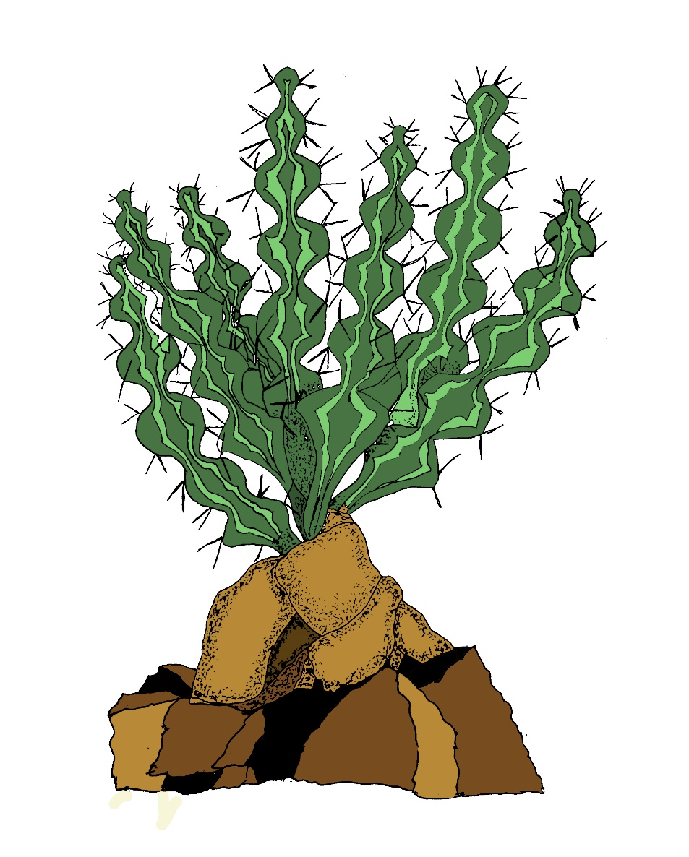
Euphorbia pseudoburuana

August 5-7, 2022
Los Angeles County Arboretum
301 N Baldwin Ave, Arcadia

Competitive entries shall be as follows:
NOVICE Exhibitor has won no more than 40 blue ribbons total in recognized CSS shows.
ADVANCED Exhibitor has won 41 or more blue ribbons. No Commercial sellers.
OPEN Exhibitor must have won 80 or more blue ribbons or be a commercial seller of Cacti or Succulents.
Set-up Times
Wed. 3rd 1:00 pm to 6:00 pm, Thurs. 4th, 8:00 am to 9:00 pm and Fri. 5th 9:00 am to 5:00 pm.
The sales area will be open at 9:00 pm Friday. The Show will be closed on Friday the 5th.
All entrants must register their total entries in the show registrar prior to placement on tables.
Judging will begin at 5 pm on Friday the 5th.
Take-out Time is Sunday the 7th from 5:00 pm. Plants must remain for the entire show.
All Plants must be removed Sunday Evening.
Judging Scale
Condition of plant - 60 points
Size and degree of Maturity - 15 points
Staging and presentation - 20 points
Nomenclature - 5 points
Points awarded towards trophies; First = 6 points, Second = 3 points, Third = 1 point

DIVISION 1 CACTI
Class | Category | Class | Category
1 | Ariocarpus up to 5” | 30 | Sclerocactus, Pediocactus
2 | Ariocarpus solitary over 5” | 31 | Opuntia North American
3 | Ariocarpus solitary over 5” | 32 | Cereus North American
4 | Obregonia, Strombocactus, Ortegocactus | 33 | Opuntia South American
5 | Astrophytum | 34 | Cereus South American
6 | Aztekium, Pelecyphora, Epithelantha, Geohintonia | 35 | Copiapoa
7 | Stenocactus, Echinofossulocactus | 36 | Eriosyce, Neoporteria, Islaya
8 | Echinocactus, Echinomastus | 37 | Matucana, Submatucana, Oroya
9 | Ferocactus, Hamatocactus, Leuchtenbergia | 38 | Rebutia, Aylostera
10 | Echinocereus clusters up to 6” | 39 | Weingartia (inc. Sulcorebutia) to 6 inches
11 | Echinocereus clusters over 6” | 40 | Weingartia (inc. Sulcorebutia) cluster over 6”
12 | Echinocereus solitary | 41 | Gymnocalycium up to 5”
13 | Thelocactus | 42 | Gymnocalycium solitary over 5
14 | Escobaria | 43 | Gymnocalycium clusters 5” to 8”
15 | Coryphantha | 44 | Gymnocalycium clusters over 8”
16 | Cochemeia, Mammilloydia, Mammillopsis | 45 | Lobivia, Echinopsis, Trichocereus
17 | Mammillaria single hooked up to 7” | 46 | Parodia, Notocactus
18 | Mammillaria single hooked over 7” | 47 | Frailea, Blossfeldia, Mila
19 | Mammillaria w/o hooks single to 7” | 48 | Melocactus
20 | Mammillaria w/o hooks single over 7” | 49 | Discocactus
21 | Mammillaria normally solitary with multiple heads | 50 | Buiningia, Uebelmannia
22 | Mammillaria hooked cluster to 7” | 51 | Epiphytic cacti
23 | Mammillaria hooked cluster over 7” to 10” | 52 | Any other genus
24 | Mammillaria hooked cluster over 10” | 53 | Crests
25 | Mammillaria cluster w/o hooks up to 7” | 54 | Monstrose
26 | Mammillaria cluster w/o hooks over 7” to 10” | 55 | Variegated
27 | Mammillaria cluster w/o hooks over 10” to 14” | 56 | Seed grown by exhibitor up to 5 years
28 | Mammillaria cluster w/o hooks over 14” | 57 | Miniature (staged as min.) 3” max pot
29 | Turbinicarpus, Gymnocactus, Neolloydia | 58 | Collection of 5 to 12 plants

DIVISION 2 Succulents
CLASS | CATEGORY | CLASS | CATEGORY
59 | Agave, Yucca up to 6” | 94 | Haworthia clusters non-retuse
60 | Agave, Yucca over 6” | 95 | Haworthia single
61 | Variegated Agavaceae | 96 | Gasteria (includes variegates)
62 | Calibanus, Beaucarnea, Nolina, Dioscorea, Testudinaria | 97 | Pachypodium African over 5”
63 | Aloe up to 6” | 98 | Pachypodium Madagascar over 5”
64 | Aloe over 6” | 99 | Pachypodiums under 5” All
65 | Fouquieria, Idria | 100 | Adenia
66 | Pachycormus | 101 | Adenium
67 | Bursera, Commiphora | 102 | Lithops up to 3”
68 | Operculicarya | 103 | Lithops over 3”
69 | Portulacaceae | 104 | Conophytum, Lapidaria, Dinteranthus
70 | Curcurbitaceae | 105 | Mesembs without prominent roots
71 | Cissus, Cyphostemma up to 7” | 106 | Mesembs with prominent roots or trunks
72 | Cissus, Cyphostemma over 7” | 107 | Didieraceae, Alluaudia
73 | Aeonium, Greenovia, Sempervivum | 108 | Trichocaulon, Hoodia, Pseudolithos
74 | Crassula, Cotyledon, Kalanchoe | 109 | Other stapeliads
75 | Tylecodon | 110 | Fockea
76 | Adromischus | 111 | Other caudiciform asclepiads
77 | Graptopetalum, Pachyphytum, Tacitus | 112 | Senecio, Hoya, Ceropegia, Dischidia
78 | Sedum | 113 | Sarcocaulon, Pelargonium, Othonna
79 | Dudleya | 114 | Sansevieria (may include variegates)
80 | Echeveria up to 6” | 115 | Bromeliaceae - Dyckia, Hechtia, etc.
81 | Echeveria over 6” | 116 | Dorstenia, Ficus
82 | Euphorbia medusa type | 117 | Pedaliaceae
83 | Euphorbia stem type up to 5” | 118 | Ipomea
84 | Euphorbia stem type over 5” | 119 | Bulbs
85 | Euphorbia Madagascar caudiciform to 4” | 120 | Succulent Orchids
86 | Euphorbia Madagascar caudiciform over 4” | 121 | Cycads
87 | Euphorbia other Madagascar to 6” | 122 | Any other Genus
88 | Euphorbia other Madagascar over 6” | 123 | Crests
89 | Euphorbia other caudiciform up to 6” | 124 | Monstrose
90 | Euphorbia other caudiciform over 6” | 125 | Variegated
91 | Monadenium, Jatropha | 126 | Seed grown by exhibitor up to 5 years
92 | Astroloba, Tulista | 127 | Miniature (staged as min.) 3” max pot
93 | Haworthia clusters, retuse type | 128 | Collection of 5 to 12 plants
Division 3 -Arrangements
129 Dish gardens, planters 130 Bonsai Cactus or Succulent
Division 4 – Displays
131 Individual Display 132 Education Display 133 Commercial Display
Division 5 - Allied Interests
134 Photography 1 135 Artwork and Handicrafts 136 Ikebana and artistic plant displays
Show Rules
The Inter-City Show is open to anyone wishing to enter. Those wishing to enter who are not members of one of the host clubs should contact a Show Chairman at least one week prior to the show.
Plants entered in the show competition should have been in the owner’s possession a minimum of 6 months.
Plants entered in the show should not be field collected.
All plants must be free of pests - the show committee may remove any unsuitable material from the Show or Sale at any time.
Exhibits should be marked with the owner’s name not visible to the judges. Exhibitors are responsible for placing entry cards with exhibits prior to the judging. All judge’s decisions are final, and the show committee decisions are final.
Awards and exhibits must remain until the end of the show, 5 pm Sunday August 7, 2022.
The three host clubs and the show committee will not assume responsibility for the loss or injury of property.
The show committee reserves the right to move or adjust plants, categories or displays to improve or facilitate a better show.
All commercial growers or vendors in the Inter-City Show must either enter a display or enter a minimum of 10 plants in the Open class.
Inch measurements as indicated in the show categories refer to the inside diameter of the pot.
Plants with 30% or more Variegation, Crest, or Monstrose may only appear in such categories except for variegation in Gasteria and Sansevieria.
A Rookie novice is one who has not shown more than 10 plants cumulative.
Plant stands may only be used in the Bonsai class or with plants that cascade below the bottom edge of the pot.
For odd-shaped pots, size is determined by adding the length and width together and dividing by two.
Awards
First, second and third place ribbons will be awarded in each class from Divisions 1 to 5.
Special Rosettes will also be given for 24 outstanding entries.
Trophies kept by the winners include: Sweepstakes overall show, Best Cactus and Best Succulent in all three classes, High Points Cactus and High Points Succulents in all three classes.
Trophies awarded as perpetuals include:
- Intercity Annual Show Best U.S. Cactus Trophy Donated by Charles & Joann Spotts
- Best Argentine Cactus Trophy Donated by Victor Turecek
- Best Chilean Cactus Plaque donated by Betty & Ed Gay
- Intercity Cactus & Succulent Show Best Ariocarpus Trophy Donated by Larry Grammer
- Best Astrophytum In Show In Honor of Carol Ann Wujcik Inter-City Cactus And Succulent Show Trophy Donated by Cactus Data Plants And The San Gabriel Valley And Succulent Society
- Inter-City Cactus & Succulent Show Best Cereus Trophy Donated by Brigitte Williams
- Intercity Cactus And Succulent Show Best Echinocereus Trophy Donated by Steve Plath
- Inter-City Cactus & Succulent Show Best Gymnocalycium Trophy Donated by Jim and Ronnie Leong
- Doran Black Trophy for Inter-City Cactus And Succulent Show Best Mammillaria Donated by John Cooper
- Ted Taylor trophy for Intercity Cactus & Succulent Show Award for Best Opuntia donated by Joe & Kitty Sabo Otis & Lillian True
- Inter-City Cactus & Succulent Show Best Rebutia/Sulcorebutia Plaque Donated by Steve Frieze
- Fred A. Hutflesz Jr. Memorial Award for the Best Epiphytic Cactus Donated by Rainbow Gardens
- Best Crested Cactus Donated by Betty & Ed Gay
- Inter-City Show Best Variegated Cactus Plaque Donated by Gene and Laura Oster
- Southern California Inter-City Cactus & Succulent Show Best Exhibit Dedicated to Excellence in Memory of Rose & Tony D'Attilio Donated By Michael & Joyce Buckner Mohave Desert Suiseki Stone Trophy Created By Monte Woodworth
- The Otis And Lillian True Trophy for Best Allied Interest Donated by Joe and Carol Wujcik
- InterCity Annual Show Best Caudiciform Presented by House of Cactus, W. Doran Black Memorial Award
- Intercity Cactus & Succulent Show David Grigsby Trophy Best Madagascar Plant Other Than Euphorbia
- Inter-City Cactus & Suuculent Show Ellen Low Award for Best Anacardiaceae
- Frank Horwood Annual Memorial Award Best Non-Madagascan Euphorbia Donated by Abbey Gardens
- The Harry Johnson Award for Best Madagascar Euphorbia donated by the C & J Nursery
- August Brietung Trophy for Best Agave in Show Donated by Darrel and Audrey Tucker
- Best Aloe trophy donated by R.S.V.P.
- Best Miniature Aloe Hybrid Inter-City Cactus & Succulent Show John Bleck Award Sponsored by Gregg DeChirico
- Intercity Cactus And Succulent Show Best Asclepiad Trophy Donated by Sandy Chase
- Best Crassula Plaque Intercity Cactus & Succulent Show Donated by Norma Lewis
- Best Echeveria Challenge Trophy Donated by R.S.V.P.
- Bill Low trophy for Best Fouquieria donated by the L.A.C.S.S.
- Intercity Cactus & Succulent Show Award for Best Gasteria Donated by Pat & Andy Staab
- Inter City Annual Show Best Haworthia Trophy Presented by C.W. Elliott
- Ed Storm trophy for Best Mesemb., donated by Singer’s Growing Things
- Inter-City Cactus & Succulent Show Best Dyckia in Memory of Bill Baker Donated by Steve Ball and Mike Boess of San Fernando Valley Bromeliad Society
- Best Pachypodium Donated by Tom and Carol Loehman
- Annual Inter-City Cactus And Succulent Show Best Bonsai Succulent in Honor of Dennis Junke Donated by the L.A.C.S.S
- Best Crested Succulent Inter-City Cactus & Succulent Show donated by Dave & Eileen Tufenkian
- Best Variegated Succulent Intercity Cactus & Succulent Show
- Best Lithops Inter-City Cactus And Succulent Show In Memory of Larry Grammer
- Inter-City Cactus And Succulent Show C.W. Elliott Award for Best Collection donated by Sharon & Bob Thoerner
- Best Staged Plant in ICCSS in honor of Mike Buckner, Larry Grammer, Steve Southwell donated by Cactus Data Plants
- Intercity Cactus & Succulent Show Best Any Other Genus
- Inter City Cactus & Succulent Show Best Miniature Cactus or Succulent in the Show donated by Dick and Lupe Hulett’s Pet Plants
- Tegelberg trophy for Rarest plant in Show donated by Woody and Tambra Minnich
- Intercity Cactus And Succulent Show Best Rookie Shower Novice Succulents Donated by Artie Chavez
- Rookie Of The Year Cacti In Memory of Joe Ramos Donated by Brigitte Williams
- Inter-City Cactus & Succulent Show Dick Hulett Award for Show Spirit

